|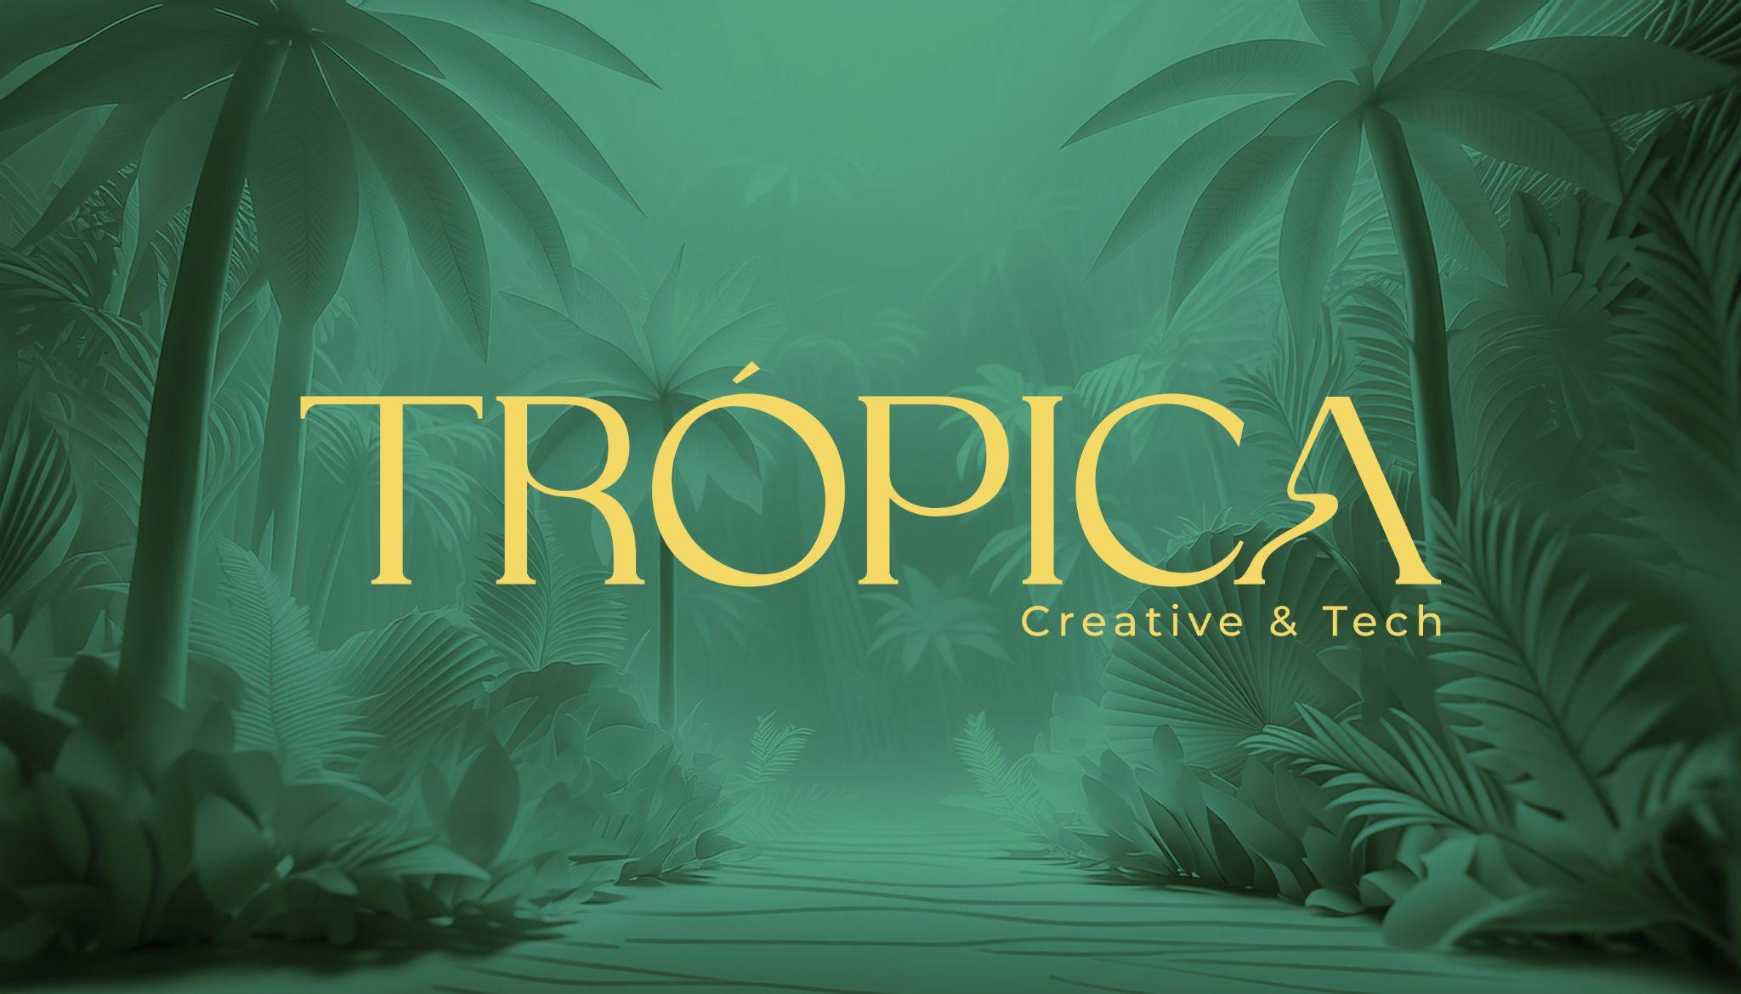

**MERCADO ADS**CREATIVE BRIEF TEMPLATE

Brief prepared by:   
Date: Jun 22, 2025

## PROJECT OVERVIEW

|  |  |
| --- | --- |
| **PROJECT NAME** |  |
| **BRAND** |  |
| **PROJECT LEAD @ MELI** |  |
| **PROJECT LEAD @ BRAND** |  |

## CAMPAIGN OVERVIEW

Campaign Type:   
☐Product Launch ☐ Seasonal Campaign ☐ Brand Awareness ☐Performance/Sales  
☐Other: _________

Markets:  
☐ Mexico ☐ Argentina ☐ Brazil ☐ Colombia ☐ Other: ___________

**TO BE FILLED OUT BY THE BRAND**

### 1. THE CHALLENGE

|  |  |
| --- | --- |
| **BUSINESS CONTEXT** *. Business situation that requires this campaign*  *. Market dynamics*  *. Competitive landscape*  *. Brand positioning challenges*  *. Seasonal/cultural timing considerations* |  |
| **BRIEF IN A TWEET** *One clear sentence describing the core challenge*  *we need to solve.* |  |
| **KEY SUCCESS METRICS** *Commerce*  *- Sales lift*  *- Conversion rate*  *- Average order value*  *- Customer acquisition cost*  *Brand - Brand awareness lift - Purchase intent - Brand association metrics - Social sentiment*  *Engagement - Content engagement rates - Share of voice (SOV) - User-generated content volume - Platform-specific metrics* | **PRIMARY :**    **SECONDARY :** |

### 2. STRATEGIC FOUNDATION

|  |  |
| --- | --- |
| **TARGET AUDIENCE** *- Demographics: Age, Gender, Income, Location*  *- Psychographics: Interests, Values, Lifestyle*  *- Shopping behavior on Mercado Libre*  *- Cultural insights (especially for LATAM markets)* | **PRIMARY :**  **SECONDARY:** |
| **KEY CONSUMER INSIGHT** *The fundamental human truth that drives the creative strategy :* |  |
| **BRAND TRUTH** *What authentic brand characteristics can we leverage?* |  |
| **CULTURAL CONTEXT** *Relevant cultural moments, trends, tensions, celebrations, regional nuances, etc.* |  |
| **KEY COMPETITORS** |  |
| **COMPETITIVE DIFFERENTIATION** *How will the brand/the campaign stand out?* |  |

### 3. CREATIVE STRATEGY

|  |  |
| --- | --- |
| **CREATIVE CONCEPT**  *Is there already a campaign idea or a concept for other media placements? Please share it with us, as it is really important for us to build our ideas on top of that* | XX |
| **KEY MESSAGE** *What is the single most important thing we want consumers to remember?* | XX |
| **EMOTIONAL TERRITORY** *What feeling should the campaign evoke?* | XX |

### 4. CAMPAIGN ARCHITECTURE

|  |  |
| --- | --- |
| **CAMPAIGN TAGLINE/THEME** *The consistent message across all touchpoints.* | XX |
| **CONTENT PILLARS** | XX |

### 5. APPENDIX

|  |  |
| --- | --- |
| **KEY FILES** *These assets are essential in order to kick off the creative work. You can share them through a link here or via email. Please make sure to provide access to micaela@tropica.me* | ☐Campaign deck (if available, it can be a WIP) ☐Campaign Key Visual in an editable version (if available, it can be a WIP) ☐Brand book and Brand guidelines ☐Brand logo ☐Product shot |
| **NICE TO HAVE FILES** *You can share them through a link here or via email. Please make sure to provide access to micaela@tropica.me* | ☐Campaing video (if available, it can be a WIP) ☐Influencer list (if available) ☐Pictures featuring people using the product or suitable for the campaign *(Kantar highlights the use of people as a best practice for ads).* |

**TO BE FILLED OUT BY MERCADO LIBRE**

### 6. MELI ECOSYSTEM INTEGRATION

|  |  |
| --- | --- |
| **PLATFORM ADVANTAGES TO LEVERAGE** | ☐ Delivery network and logistics ☐ Regional market penetration ☐ Local cultural knowledge ☐ E-commerce ecosystem ☐ Meli Play streaming platform ☐ Disney+ partnership opportunities ☐ Other: ___________ |

### 7. CAMPAIGN ARCHITECTURE

|  |  |
| --- | --- |
| **PROMOTIONAL MECHANICS** *What can we offer?* | ☐Discount/offers ☐ Bundle deals ☐ Limited time offers ☐ Free shipping promotions ☐ Users contest ☐ Prizes/merchandising ☐ Product sampling ☐ Other: ___________ |

### 8. MEDIA ECOSYSTEM

|  |  |
| --- | --- |
| **MERCADO ADS CORE FORMATS**  **FOR THIS CAMPAIGN** *These should be included with key visuals In the creative pitch deck.* | ☐Home Slider (display) ☐ RTB Banners (display) ☐ MeLi Play (video)  ☐ HBO Max (video)  ☐ RokuTv (video) ☐ Disney+ (video) ☐ Landing page  ☐ Mi página (Requiere revisión previa con equipo de Trópica) ☐ Other: ___________ |
| **MERCADO ADS AMPLIFICATION** *These should be included with key visuals In the creative pitch deck.* | ☐ Emailing ☐ MeLi App Push notifications ☐MeLi Social Media ☐ MeLI PR/Earned media ☐ OOH/DOOH ☐ BTL (ie. MeLi Arena Sao Paulo)  ☐ Affiliates ☐ Interactive digital experience *(please keep in mind that this requires developing an external website and is not included on the Creative Pulse scope)* ☐ Other: ___________ |

### 9. PRODUCTION CONSIDERATIONS

|  |  |
| --- | --- |
| **TIMELINE** *Please note that* ***we require at least 10 working days*** *to complete a creative proposal. If the time available is shorter, please reach out to TRÓPICA’s POC* | Campaign launch date : Jun 22, 2025  Campaign duration : XX |
| **BUDGET** | Media spend on Mercado Ads : $  Assets production budget : $  Talent/influencer budget : $  Social media amplification budget : $  Activation/events budget : $  Other : ___________ |
| **CONTENT TYPE REQUIRED FOR ASSETS PRODUCTION** *Which assets do you anticipate we'll need to develop moving forward to prepare for the campaign launch?* | ☐ Video content (6”, 15”, 30”) ☐Home Sliders ☐RTB ☐Landing page elements ☐ Influencers content ☐ Social Media Assets ☐ Other: ___________ |

### 10. APPENDIX

|  |  |
| --- | --- |
| **ADDITIONAL INFORMATION** *You can share them through a link here or via email. Please make sure to provide access to micaela@tropica.me* | ☐ Audiences/category data ☐ Previous campaigns performance data ☐Market research insights ☐ Legal requirements (if needed) ☐ Other: ___________ |